EXPT NO:8 | FORECASTING AND PREDICTIVE ANALYTICS USING TABLEAU  AND POWER BI
DATE: 14.08.2026

PRE-LAB QUESTIONS (PROVIDE BRIEF ANSWERS TO THE FOLLOWING QUESTIONS)

- What is forecasting in the context of Business Intelligence (BI)?
Forecasting in Business Intelligence is the process of using historical data to estimate future values or trends. In this experiment forecasting is applied to historical sales data to predict future sales performance. Tableau and Power BI can use time series data to generate forecasted values and visualize future trends. Forecasting helps organizations understand possible future outcomes and supports planning decisions related to sales inventory promotions and resource allocation.

- Explain the difference between predictive analytics and descriptive analytics.
Descriptive analytics focuses on understanding what has already happened by analyzing historical data through reports dashboards and visualizations. Predictive analytics goes further by using historical patterns statistical methods and forecasting techniques to estimate what may happen in the future. In this experiment historical sales data is analyzed and forecasting is used to predict future sales trends. Therefore descriptive analytics explains past sales performance while predictive analytics helps estimate future sales and expected business outcomes.

- Name two common forecasting methods used in Tableau and Power BI.
Two forecasting approaches relevant to Tableau and Power BI are time series forecasting using exponential smoothing and forecasting based on moving averages. Tableau provides a built in Forecast feature that can use exponential smoothing models and display prediction intervals. Power BI can also provide built in forecasting through line charts and can optionally use DAX calculations for prediction using methods such as moving averages or linear regression. These approaches use historical patterns to estimate future sales values.

- Why is data granularity important for accurate forecasting?
Data granularity determines the level at which historical observations are analyzed such as daily weekly or monthly sales. Appropriate and consistent granularity is important because forecasting models depend on regular time intervals to identify trends and seasonal patterns. If data contains irregular intervals or inconsistent aggregation the forecast may become less reliable. In this experiment sales data should therefore be aggregated at a suitable level such as daily weekly or monthly before applying forecasting techniques in Tableau or Power BI.

- Name two challenges in forecasting using multiple data sources.
Two common challenges are missing data and irregular time intervals. Missing sales values can create gaps in the historical time series and make it difficult for forecasting models to identify reliable patterns. Irregular dates or inconsistent time intervals can also affect trend and seasonality detection. When multiple sources are integrated additional problems may occur if date formats field names or data types are inconsistent. Therefore the datasets should be cleaned standardized and validated before forecasting.

IN-LAB EXERCISE:
OBJECTIVE:
To perform time series forecasting and predictive analytics on historical sales data using Tableau and Power BI, and visualize future trends for informed decision-making. PROCEDURE:
- Data Collection:
  - Import historical sales data from multiple sources:
    - Dataset 1: Sales Data (CSV) → Order ID, Order Date, Region, Sales Amount
    - Dataset 2: Promotions Data (Excel) → Promotion ID, Region, Promotion Start Date, Promotion End Date, Discount
- Data Preparation and Transformation:
  - Clean data: standardize date formats, remove duplicates, handle missing values.
  - Aggregate sales data at the required granularity (daily, weekly, or monthly).
  - Ensure numeric fields (Sales, Discount) are correct.
- Data Integration and Modeling:
  - Tableau: Connect datasets and relate them using the Region field.
  - Power BI: Create relationships in the Model view; define cardinality where necessary.
- Forecasting and Predictive Analytics:
  - Tableau:
    - Use the Forecast feature on Sales over time. o Apply trend models like Exponential Smoothing and visualize prediction intervals.
  - Power BI:
    - Use built-in forecasting in line charts. o Optionally, create a DAX measure for predicted sales using moving averages or linear regression.
- Create Calculated Fields:
  - Forecasted Sales = Predicted value from the model
  - Sales Growth % = ((Forecasted Sales – Actual Sales) / Actual Sales) * 100
- Design a Comprehensive Dashboard:
  - Line chart showing actual vs. forecasted sales over time.
  - KPI cards: Total Forecasted Sales, Expected Growth %.
  - Use combo charts to show sales trends along with promotion periods.
  - Highlight regions with expected growth above or below target thresholds.
- Validate Forecast Accuracy:
  - Compare forecasts against actual historical sales (back-testing).
  - Adjust forecasting parameters if necessary (e.g., seasonality length, smoothing factor).
- Publishing and Sharing:
  - Tableau: Publish workbook to Tableau Public or Tableau Server.
  - Power BI: Publish report to Power BI Service and share with stakeholders.
Experiment Datasets:
  - Dataset 1: Historical Sales Data (CSV) → Order ID, Order Date, Region, Sales
  - Dataset 2: Promotions Data (Excel) → Promotion ID, Region, Promotion Start/End Date, Discount

Screenshot of PowerBI
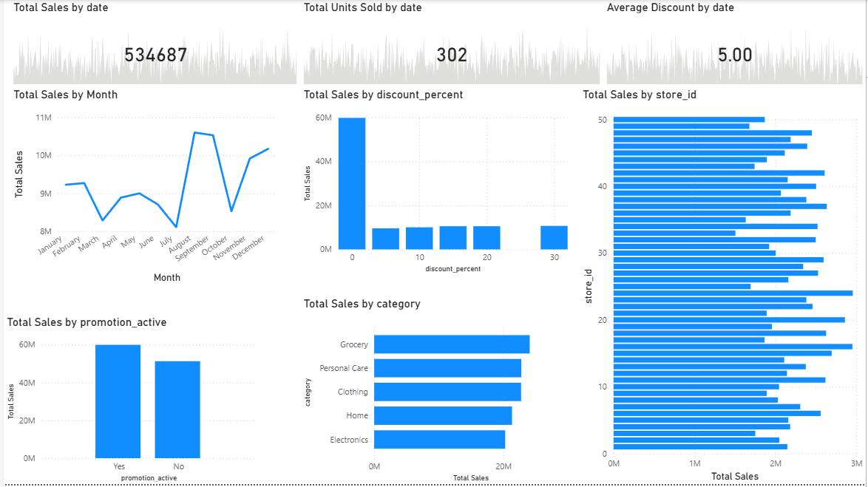

Screenshot of Tableau
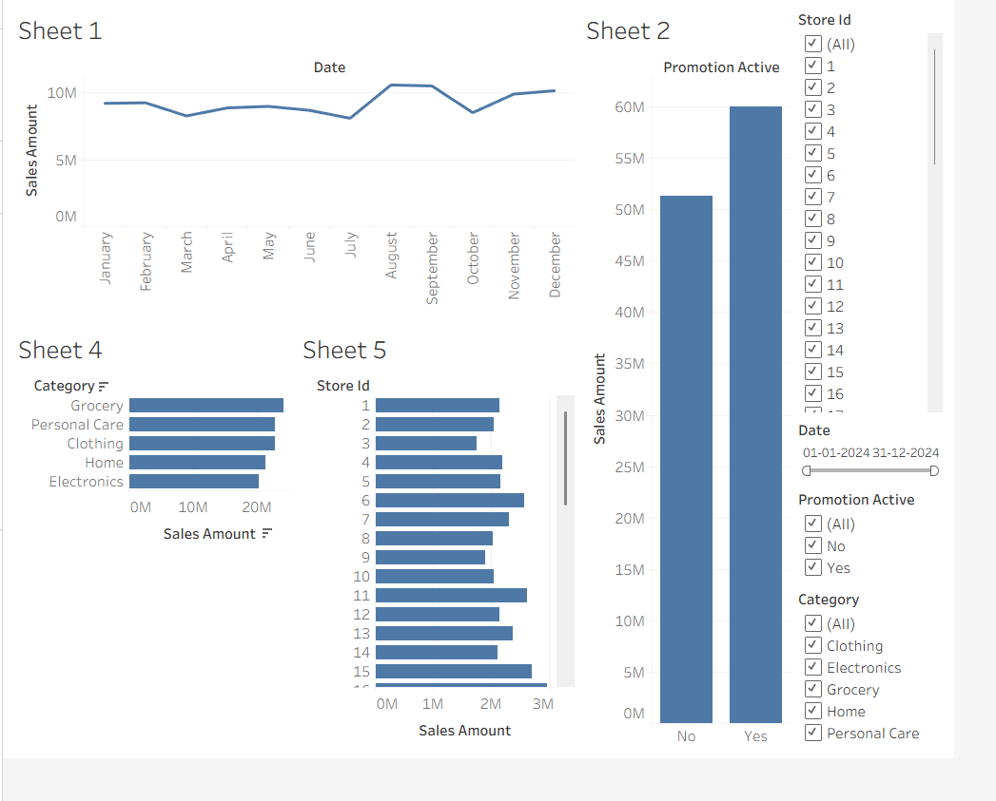
POST-LAB QUESTIONS (PROVIDE BRIEF ANSWERS TO THE FOLLOWING QUESTIONS)
- How did forecasting help in predicting future sales trends for business planning?
Forecasting helped estimate future sales trends by analyzing historical sales patterns over time. The forecast visualization provided an expected direction for future sales and allowed actual historical performance to be compared with predicted values. This information can support business planning by helping managers anticipate future demand and prepare resources accordingly. Forecasting can also assist with decisions related to inventory promotions staffing and sales planning. Therefore it provides a data driven basis for preparing for possible future business conditions.

- What forecasting method did you use, and why was it suitable for the dataset?
The forecasting method used was the built in time series forecasting feature with exponential smoothing as specified in the experiment. This method is suitable for historical sales data because sales are recorded over time and may contain trends or seasonal patterns. Exponential smoothing gives importance to recent observations when estimating future values. Tableau can visualize the forecast together with prediction intervals while Power BI can provide built in forecasting through line charts.

- What challenges, if any, did you face regarding missing data or irregular time intervals?
One challenge in forecasting can be missing observations or irregular time intervals in the historical sales data. Forecasting models work more reliably when observations are consistently recorded over time. Missing values can create gaps while irregular intervals can make it difficult to identify trends and seasonal patterns correctly. The experiment addresses this by requiring the data to be cleaned and sales to be aggregated at an appropriate daily weekly or monthly granularity. Proper data preparation improves the reliability of the resulting forecast.

- How can predictive analytics influence decision-making in a retail environment?
Predictive analytics can help retailers make decisions by estimating future sales demand and identifying expected performance patterns. Forecasts can support inventory planning by helping businesses anticipate future demand and avoid excessive or insufficient stock. Predictive insights can also assist with promotion planning and regional performance evaluation. By combining historical sales with promotional information retailers can better understand possible future outcomes. This allows managers to make more informed decisions based on expected trends rather than relying only on historical results.

- What additional data (e.g., competitor pricing, economic indicators) could be integrated to improve forecast accuracy?
Additional information such as competitor pricing and economic indicators could improve forecast accuracy by providing factors that may influence customer demand. Competitor pricing can help identify how changes in market prices affect sales while economic indicators can provide information about broader market conditions. Other useful sources could include promotional activity inventory levels holidays and customer behavior. Integrating these variables with historical sales data can provide more context to the forecasting model and potentially improve its ability to predict future sales.

RESULT:
The historical sales and promotions datasets were successfully cleaned, integrated, and modeled in Tableau and Power BI. Forecasting techniques provided predicted sales trends, growth percentages, and region-wise performance expectations. The resulting dashboards allowed managers to visualize actual vs. forecasted sales, enabling better planning and datadriven decision-making.

ASSESSMENT

Description |  | Max Marks | Marks Awarded
Pre Lab Exercise |  | 5
In Lab Exercise |  | 10
Post Lab Exercise |  | 5
Viva |  | 10
 | Total | 30
 | Faculty Signature

